# Project Documentation

1. Project Title

* InsightStream: Navigate the News Landscape

# 2. Introduction

Project Title: InsightStream

* Team ID: NM2025TMID40475
* Team Size: 4

Team Leader:

* SRI RAJARAJESHWARI C (sriraji938@gmail.com)

Team Members:

* ROHINI V (vrajeshwari8181@gmil.com)
* KAVIYA KERTHIKA G D (kavyakerthika@gmail.com)
* JAYA SRI E (ejayasri62@gmail.com)

# 3. Project Overview

* Purpose: InsightStream helps users navigate the news landscape effectively.
* Features:
* Personalized news feed
* Category-based filtering
* Real-time updates
* User-friendly interface

# 4. Architecture

* Frontend: React.js with Bootstrap and Material UI
* Backend: Node.js and Express.js
* Database: MongoDB

# 5. Setup Instructions

* Download Node.js LTS version from https://nodejs.org/en/download/
* Install Node.js using the appropriate installer (Windows .msi or macOS .pkg).
* Open Windows PowerShell as Administrator.
* Type: set-executionPolicy unrestricted → Press Enter → Type Y → Press Enter.
* From SmartInternz portal → Go to Projects → Access Resources → Guided Projects → Workspace.
* Download the code folder from the provided link.
* Extract the downloaded ZIP file.
* Open the extracted folder in Visual Studio Code.
* Open a new terminal in VS Code.
* Run: npm install (wait for dependencies to install).
* Run: npm start (to launch the application)
* Access the app at http://localhost:3000.

# 6. Folder Structure

* InsightStream/
* |-- client/ # React frontend
* |-- server/ # Node.js backend
* |-- routes/
* |-- models/

|-- controllers/

# 7. Running the Application

* Frontend: cd client → npm start
* Backend: cd server → npm
* start Access at: http://localhost:3000

8. Authentication

* JWT-based authentication (if applicable).

# 9. User Interface

* Landing Page
* User Dashboard
* Admin Panel
* News Details Page

# 10. Testing

* Manual testing during milestones.
* Tools: Postman, Chrome Dev Tools.

1. Screenshots or Demo

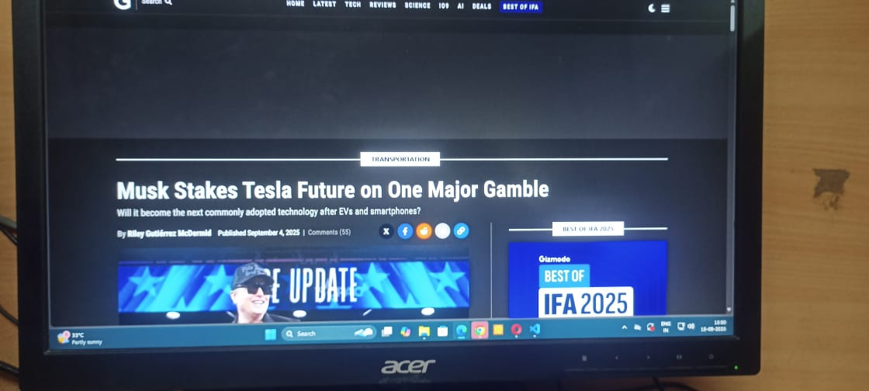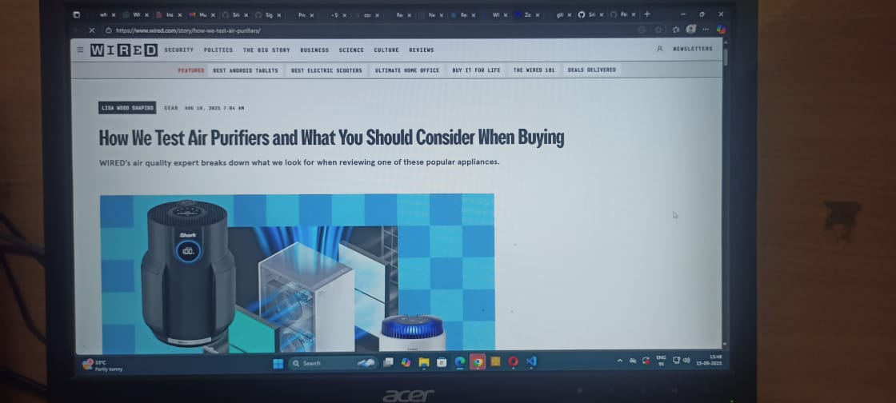

1. Known Issues

* Occasional delays in real-time updates under heavy server load.
* Minor UI inconsistencies across different devices and browsers.
* Chat message delivery might be slow when multiple users are online simultaneously.
* Some users experience login failures due to token expiration.
* Feedback submission occasionally fails due to network interruptions.
* Admin panel controls may not reflect changes immediately after updates.

# 13. Future Enhancements

* Mobile app support
* AI-based personalized recommendations
* Multilingual news support